* Open **Windows PowerShell ISE** as administrator

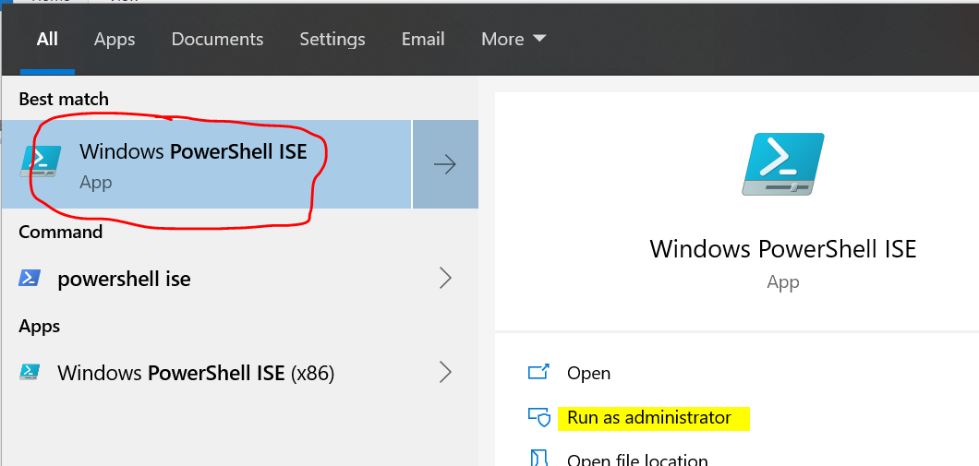

**Run below commands:**

New-Item -Type Directory -Path "C:\HWID"

Set-Location -Path "C:\HWID"

$env:Path += ";C:\Program Files\WindowsPowerShell\Scripts"

Set-ExecutionPolicy -Scope Process -ExecutionPolicy RemoteSigned

Install-Script -Name Get-WindowsAutoPilotInfo

Get-WindowsAutoPilotInfo -OutputFile AutoPilotHWID.csv

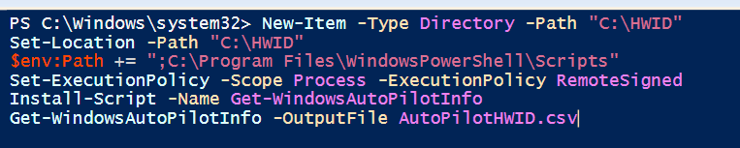

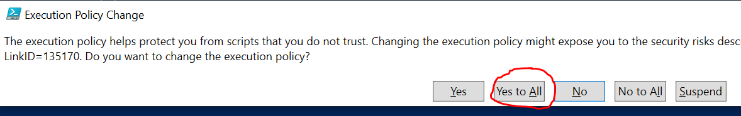

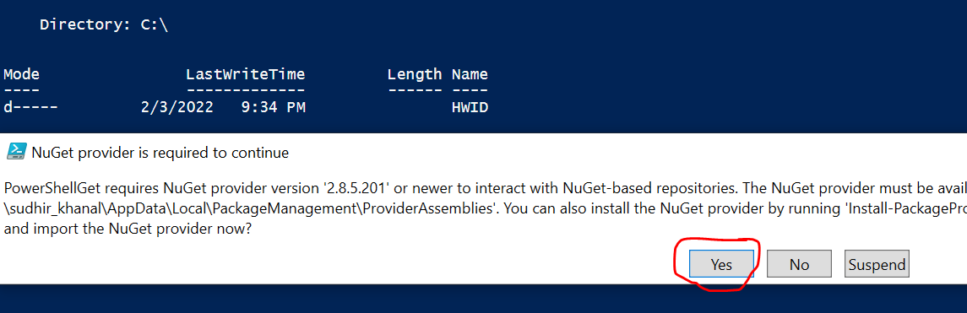

* Wait for 20-30 sec.
* You will see **HWID** folder in C Drive
* Open that and you will see **AutoPilotHWID.CSV** file.
* Attached that file and send email to [Nilesh_deshmukh@persistent.com](mailto:Nilesh_deshmukh@persistent.com)
* Dylan will add csv file in their console which will help to onboard laptop.

Rest of steps will share once laptop ready.